EVAN BROWN – UV UNWRAPPING pt 2
https://github.com/EvanBrown-Git/Essentials/blob/main/DAGV1100and1200/Maya/scenes/Diorama/Diorama16.ma
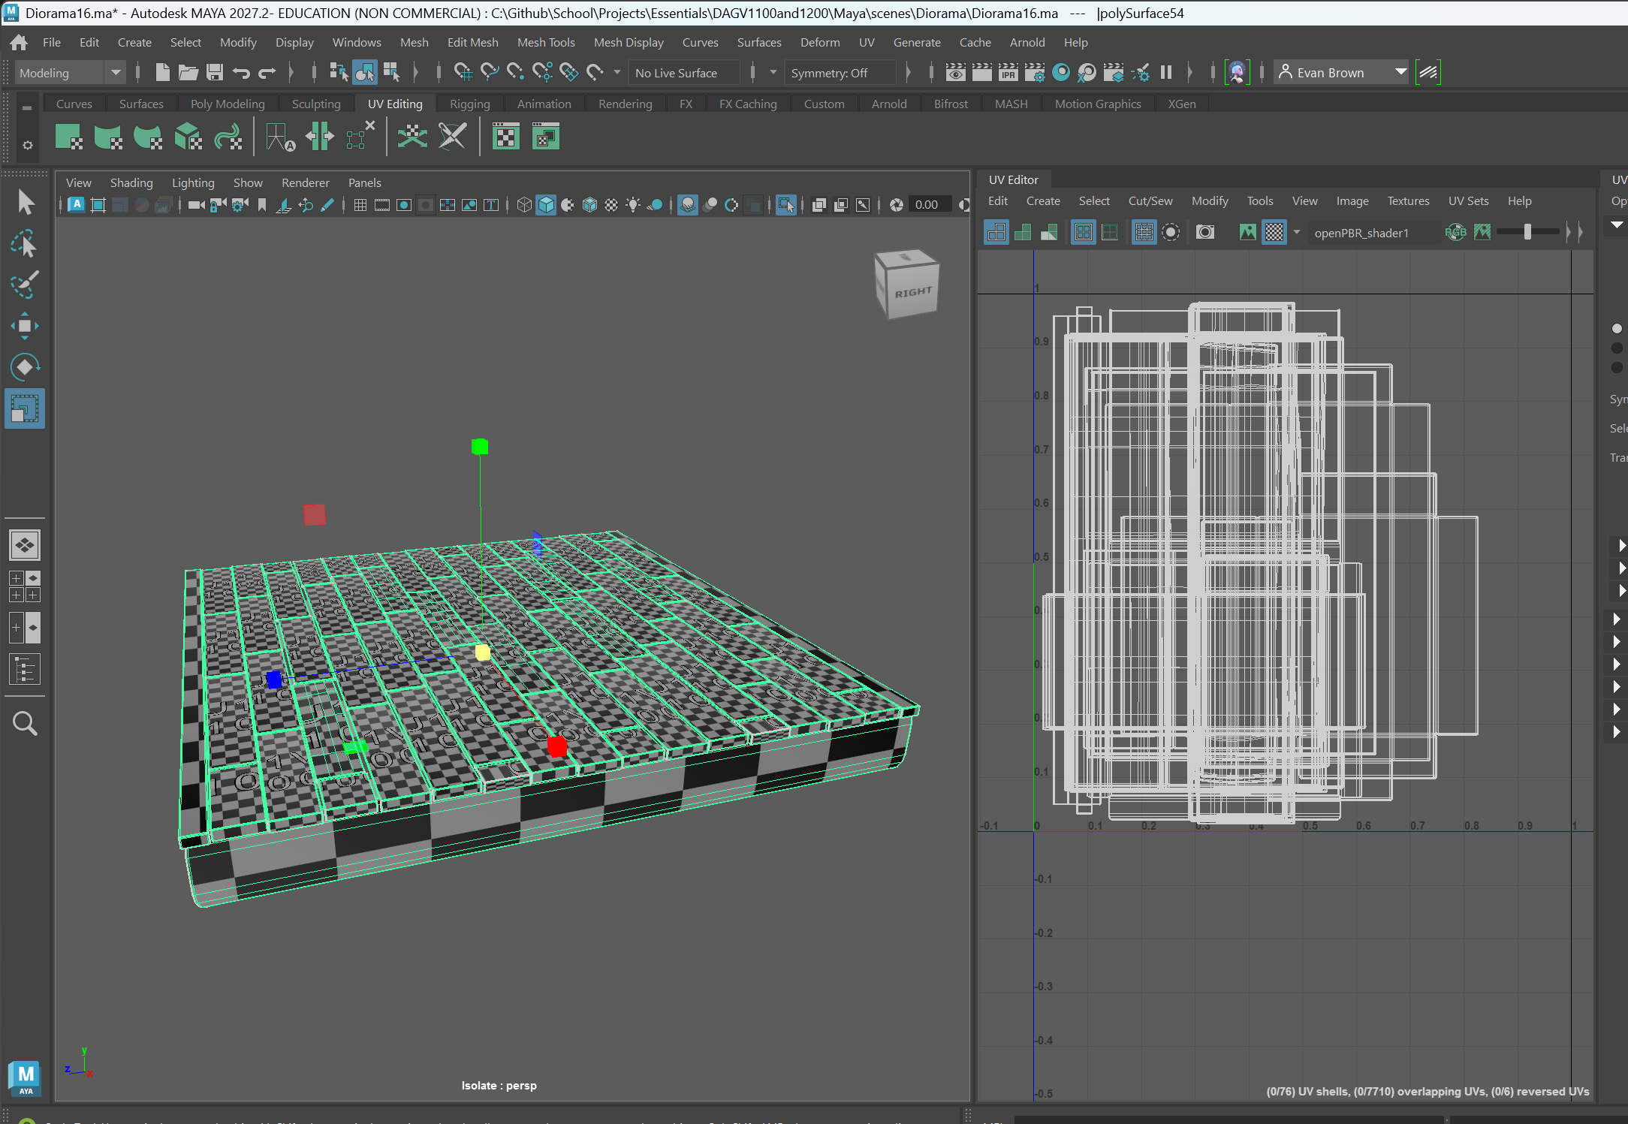
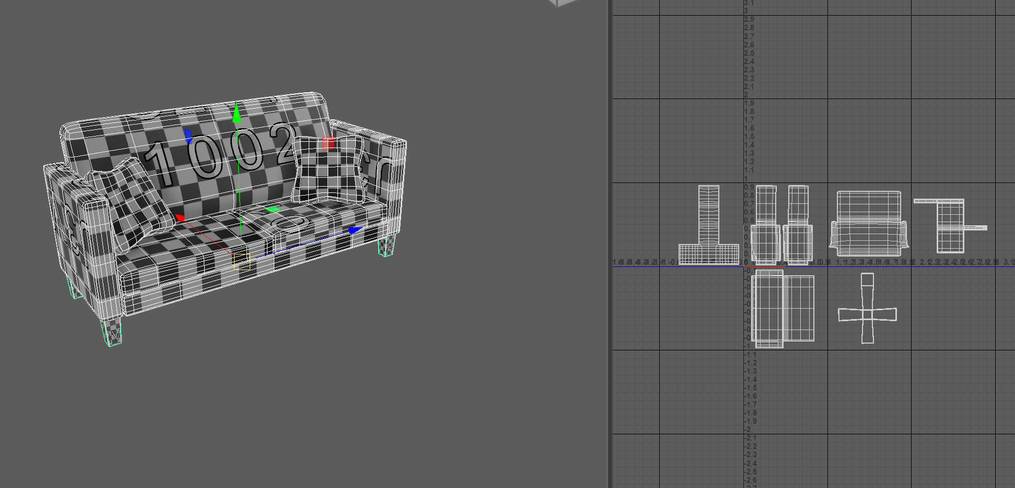
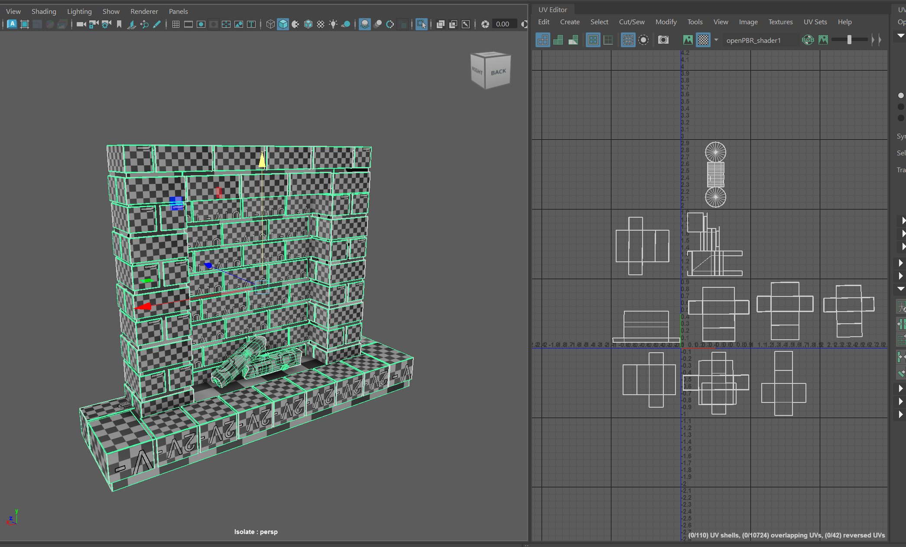
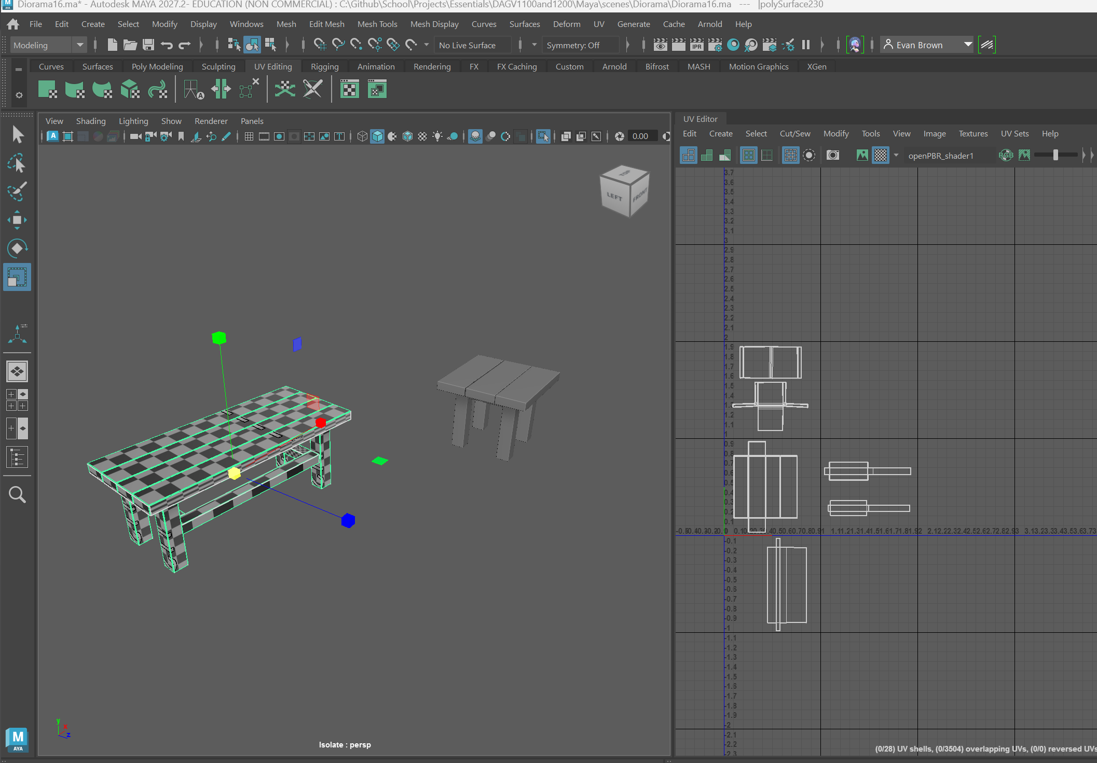
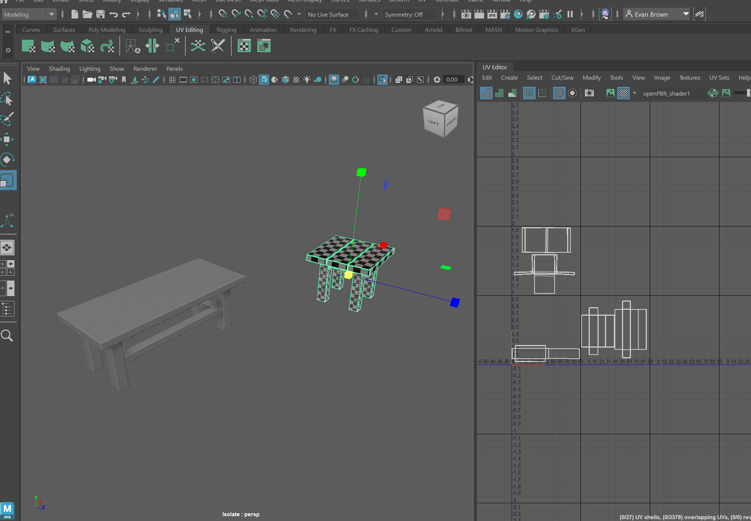
I unwrapped the couch, the Large table, the fireplace (Excluding the mantle), The second small table, and the floor.
Couch: The couch wasn’t difficult, I just added seams where the seams on actual couches would’ve been.
Large Table: The Large table was essentially the same process as the small table, with the exception of the L-brackets. I copied the Bracket data from the small table onto the ones in the big table and it worked.
Fireplace: I unwrapped each type of brick (wide, long, etc.) and then copied it onto the other ones of that type, then I unwrapped the base of back of the fireplace where I found I had made a topological mistake, I didn’t fix it, I just worked around it.
Small table: I copied the uv data from the other one, but it didn’t work so I just followed the same process.
Floor: I unwrapped the different types of floorboard, then copied them onto the others. I followed my normal unwrapping process on the base. I left the boards overlapping cause they would be taking the same texture anyway.

